Cub Scout Adult Leader Training

January 12th, 2008

“BALOO Course”

Course Description: Basic Adult Leader Outdoor Orientation (BALOO) is a course for ALL Adult Cub Scout Leaders & Parents. Whenever Cub Scouts are taken anywhere besides their normal den and pack meeting place there are BSA required procedures that must be followed. One requirement is for a BALOO trained adult to participate. Additionally, basic camping skills and equipment will be covered extensively, including some hands-on. Exceptional handouts will be supplied. This course includes a cooked lunch. THIS COURSE IS STRONGLY ENCOURAGED FOR ANYONE NOT FAMILIAR WITH FAMILY CAMPING OR BASIC CUB CAMPING SKILSS, INCLUDING PARENTS!

Pre-requisite: None.
Fast Start, New Leader Essentials, Cub Specific & Youth Protection training is helpful, but NOT required.
Fast Start & Youth Protection , On-line link – http://www.campdurant.com/choices_tng_online.html

BALOO is NOT required of Adult Webelos Leaders; however, it is STRONGLY recommended in addition to “Outdoor Leader Skills for Webelos Leaders” (OLSWL).

Required Materials: Note Taking Materials

Date: January 12th, 2008 - Saturday

Time: Sign-in: 8:45 – 9:00 AM (Requires Paid Pre-registration.)

Start: 9:00 AM

End: 5:00 PM

Cost: $ 20.00

Location: The Church of Jesus Christ of Latter-Day Saints
9880 U.S. Highway 15-501, Southern Pines, NC
(Between Circle & Pinecrest High School)

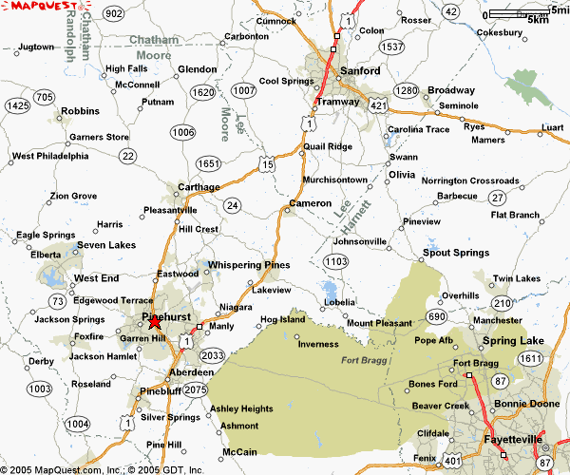
Course Directors / P.O.C. : Mel Kennedy, (910) 783 – 8924 or Maggie Kennedy, (910) 783 – 8925,
MLKennedy@nc.rr.com
Paid Registration Deadline: December 28th, 2007 - Friday
Any late registration will require the expressed approval of the course director before the course date.
Please contact the course director with any late registration requests ASAP.
(Keep Information Portion - Mail Registration Portion with Payment)

Payment & Registration Instructions:

Make checks payable to: BSA - Occoneechee Council

Mail Registration Portion & Check to:
BSA – Occoneechee Council
Attention – Training Registration
P.O. Box 41229
Raleigh, NC 27629–1229

------------------------------------------------------ Registration Form ------------------------------------------------------------

Moore District – Cub Scout BALOO Training, 12JAN08

PLEASE COMPLETE LEGIBLY !

First Name: _____________________ Last Name: _________________________________________

BSA ID #: __________________ Phone: _________________________________________________
(From Wallet Card)

e-mail: _____________________________________________________________________________

Street Address: ______________________________________________________________________

____________________________________________________________________________________

City: _________________________________________ State: __NC__ Zip Code: _____________

District: _________________________________________ Unit: __Troop_/_Pack_#_______________

Position: _______________________________________________________ Council: Occoneechee

Dietary Needs: (If none, state NONE) ____________________________________________________

____________________________________________________________________________________

____________________________________________________________________________________

