Cub Scout Adult Leader Training

February 23, 2008

“Outdoor Leader Skills for Webelos Leaders”

Course Description: “Outdoor Leader Skills for Webelos Leaders” (OLSWL) is a course for Adult Cub Scout Leaders & Parents who anticipate working with Webelos Scouts. This course is designed to familiarize Adult Webelos Leaders with necessary basic skills in Woods Tools - Fire Site & Building - Cooking & Sanitation - Ropes & Knots - Den Overnight Campout Planning – Hiking Techniques - Naturalist, Geologist, Forester, & Outdoorsman Activity Badges - Health, Safety, & Outdoor Manners - Campsite Selection, Tents, & Bedding - Flag Ceremonies - Campfire Planning. The major training focus is on OUTDOOR ACTIVITY BADGE SKILLS. OLSWL IS REQUIRED for an Adult Webelos Leader to take their Den camping; however, it is not required to be considered trained. This one-day course includes both lunch & dinner prepared within WEBELOS Scouts’ abilities.

Pre-requisite Requirement: None.
Fast Start, New Leader Essentials, Cub Specific & Youth Protection training is helpful, but NOT required.
Fast Start & Youth Protection , On-line link – http://www.campdurant.com/choices_tng_online.html

Basic Adult Leader Outdoor Orientation (BALOO) training is STRONGLY recommended in addition to Outdoor Leader Skills for Webelos Leaders but is NOT required as a pre-requisite. BALOO IS STRONGLY ENCOURAGED FOR ANYONE NOT FAMILIAR WITH FAMILY CAMPING OR BASIC CUB CAMPING SKILSS, INCLUDING PARENTS!

Required Materials: Note Taking Materials.

Date: Saturday, February 23rd, 2008

Time: Sign-in: 8:30 – 9:00 AM (Requires Paid Pre-registration.)

Start: 9:00 AM End: 9:00 PM

Cost: $ 30.00

Location: The Church of Jesus Christ of Latter-Day Saints
9880 U.S. Highway 15-501, Southern Pines, NC (Between Circle & Pinecrest High School)
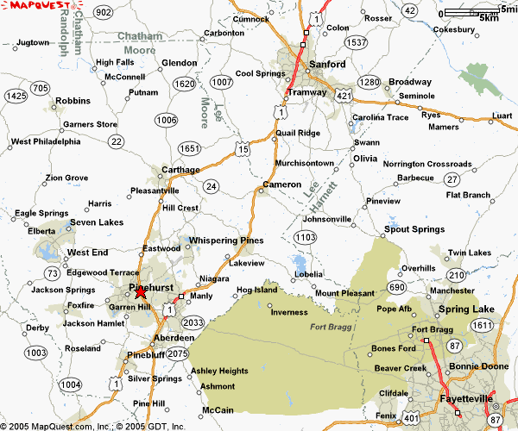
Course Directors / P.O.C. : Mel Kennedy, (910) 783 – 8924 & Maggie Kennedy, (910) 783 – 8925
MLKennedy@nc.rr.com
Paid Registration Deadline: Friday, January 12th, 2007
Any late registration will require the expressed approval of the course director before the course date.
Please contact the course director with any late registration requests ASAP.
Keep Information Portion (previous page)

Mail Registration Portion with Payment (this page)

Payment & Registration Instructions:

Make checks payable to: BSA - Occoneechee Council

Mail Registration Portion & Check to:
BSA – Occoneechee Council
Attention – Training Registration
P.O. Box 41229
Raleigh, NC 27629–1229

------------------------------------------------------ Registration Form ------------------------------------------------------------

Moore District – Cub Scout “Outdoor Leader Skills for Webelos Leaders” Training, 23FEB08

PLEASE COMPLETE LEGIBLY !

First Name: _____________________ Last Name: _________________________________________

BSA ID #: __________________ Phone: _________________________________________________
(From Wallet Card)

e-mail: _____________________________________________________________________________

Street Address: ______________________________________________________________________

____________________________________________________________________________________

City: _________________________________________ State: __NC__ Zip Code: _____________

District: _________________________________________ Unit: __Troop_/_Pack_#_______________

Position: _______________________________________________________ Council: Occoneechee

Special Dietary Needs: (If none, state NONE) ______________________________________________

____________________________________________________________________________________

____________________________________________________________________________________

____________________________________________________________________________________
____________________________________________________________________________________

____________________________________________________________________________________

____________________________________________________________________________________

